National University of Computer & Emerging Sciences



Subject: Data Mining
Project Name: Customer 360

(23L-2625 Saad Nasir)
(23L-2602 Ibrahim Moeed)
(23L-2611 Abdullah Azmat)

Deliverable Type | Progress Report
Submission Date | 29/03/2026
Instructor | Mr. Tahir Ejaz

1. PROJECT OVERVIEW
The Customer 360° project addresses a fundamental challenge in e-commerce: extracting actionable insights from massive transaction datasets. While businesses collect vast amounts of customer data, they typically answer only one question at a time, either what products sell together? or who are our customers? Our project integrates both perspectives to answer the more strategic question: 'How do product associations differ across customer segments?' Using the Olist Brazilian e-commerce dataset (100,196 transactions, 2016–2018), we combine association rule mining (Apriori & FP-Growth) with customer segmentation to build unified Customer 360° profiles. This integrated approach enables segment-specific bundling strategies, targeted marketing recommendations, and personalized cross-selling opportunities—delivering measurable business value beyond traditional analysis. Our methodology follows a rigorous four-phase pipeline:
- Data Preprocessing—consolidating 8 datasets into clean transactions with engineered features
- Association Rule Mining—discovering category-level bundling patterns with dual algorithm validation
- Customer Segmentation—identifying 3-5 natural customer clusters using RFM analysis
- Integration—mapping segment-specific purchasing patterns to derive tailored business strategies. By completing Phases 1 & 2 and establishing clear methodological validation, we have created a robust foundation for Phase 3 & 4 execution within our 3-week timeline.

2. MILESTONES ACHIEVED

PHASE 1: DATA PREPARATION & EDA (COMPLETE)

Metric | Achievement
Raw Records Processed | 100,196 rows across 8 CSV files
Clean Transactions | 96,478 orders (96.38% retention)
Data Quality | 0 null values in analysis columns
Features Engineered | derived features (RFM, AOV, recency, frequency)
Customer Segmentation Data | customer_features_kprototypes.csv ready (93,358 unique customers)
Data Validation | EDA and profiling complete
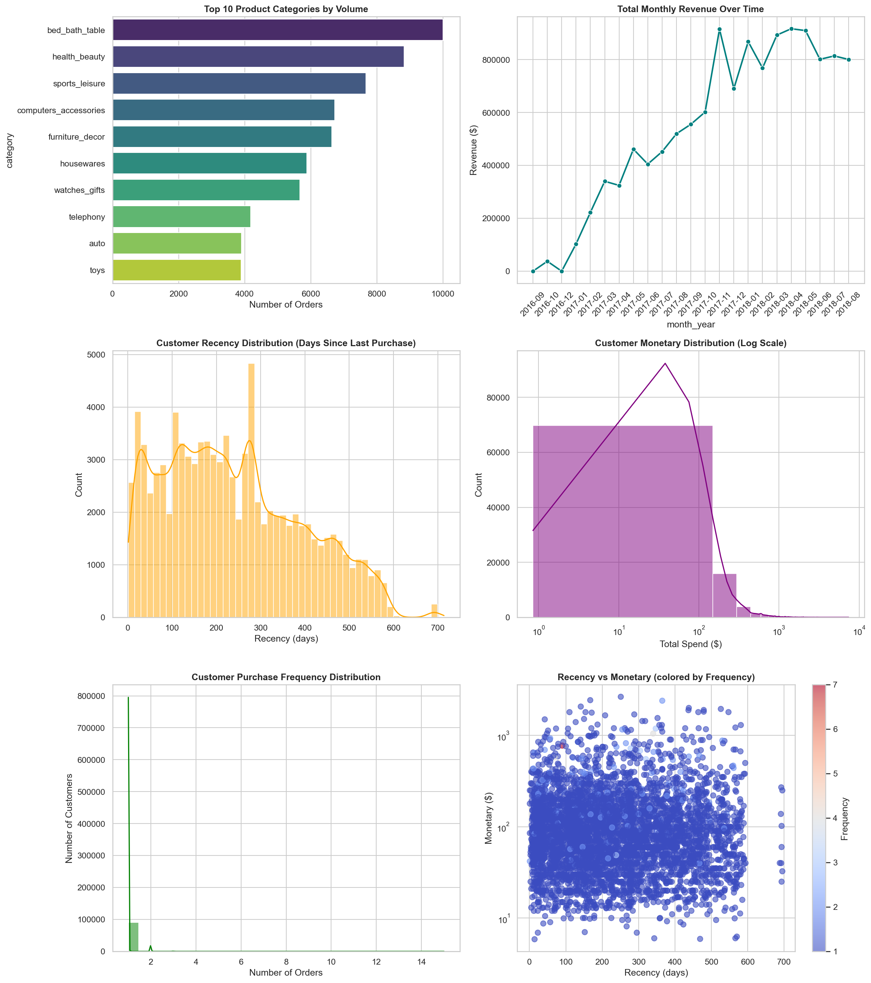Top 10 Product Categories | Recency Distribution

Deliverables: master_cleaned.csv + 4 feature engineering files

PHASE 2: ASSOCIATION RULE MINING (COMPLETE)
Metric | Achievement
Association Rules Discovered | 25 valid rules (category-level)
Algorithm Validation | Apriori + FP-Growth, 100% convergence
Dual Algorithms Applied | Both found identical 25 rules at 0.2% support
Interestingness Measures | 6 metrics (Support, Confidence, Lift, Cosine, Kulczynski, All Confidence)
Strategic Bundles | 10 synthetic bundles with SKU recommendations
Strongest Association | Children's clothes → Bags (41.05x lift, 100% confidence)
Average Statistics | Lift: 6.84x, Confidence: 52.9%, Support: 1.57%
Market Structure Insight | 99.2% single-category orders; 0.8% bundlers

Category Pair Strengths (Top 5)
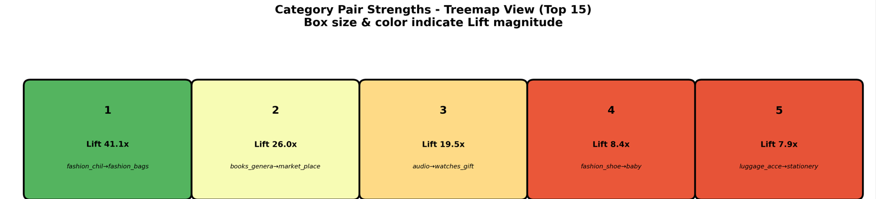

THE STRATEGIC PIVOT: PRODUCT-LEVEL vs. CATEGORY-LEVEL MINING
During Phase 2, our team initially executed Association Rule Mining at the strict Product (SKU) Level. However, diagnostics revealed extreme data sparsity (99.2% of orders contained only single items). When running algorithms across 32,000+ unique SKUs, we encountered severe Lift Inflation, where obscure products yielded mathematically perfect (but business-useless) lifts of up to 491x simply because they were purchased together exactly twice in three years.
To ensure our deliverables carried actual business value, we strategically pivoted to Category-Level Mining. By elevating the granularity, we achieved statistically robust rules (average lift of 6.84x). We engineered a Synthetic Bundling approach: pairing the #1 best-selling SKU from the Antecedent category with the #1 best-selling SKU from the Consequent category.

Evaluation Metric | Product-Level ARM (Initial Test) | Category-Level ARM (Final Pipeline) | Strategic Impact / Justification
Matrix Columns | ~32,000 Unique SKUs | 72 Product Categories | Prevents algorithm timeout
Required Support Threshold | 0.01% (0.0001) | 0.2% (0.002) | Product-level support was too low to represent meaningful customer trends.
Average Lift Output | 159.04x (Inflated) | 6.84x (Statistically Sound) | Product-level suffered from Lift Inflation (statistical flukes on rare items).
Maximum Lift Observed | 491.00x | 41.05x | 491x lift indicates two obscure items bought together exactly 2 times total.
Algorithm Used | Apriori & FP-Growth | Apriori & FP-Growth | Both approaches were rigorously cross validated using two algorithms.

CONCLUSION & NEXT STEPS
We have successfully completed Phase 1 (Data Preparation) and Phase 2 (Association Rule Mining) with rigorous methodology and defensible results. Our association rule mining identified 25 category-level bundling opportunities and synthesized 10 SKU-level bundle recommendations. Through comparative analysis with product-level mining, we successfully demonstrated why category-level logic combined with Synthetic Bundling provides superior, revenue-driving business value in sparse market basket data.
Currently, we are in progress with Phase 3 (Customer Segmentation) and Phase 4 (Integration), and we remain fully on track to deliver the complete integrated Customer 360° analysis by our April deadline.
GitHub Repository: https://github.com/sdnr1418/Customer_360

